AUCSC 218 – Assignment 3

Project 3: CRM Admin

Overview

Write a helper script which could potentially be used on any web page to visually identify the tag name of all elements on a page.

**You can work individually or in groups of up to three students**

# Instructions

1. Examine chapter09-project03.html. You will add event handlers to the two buttons at the bottom of the page. You will not need to make any changes to the supplied markup or CSS. All of your event handlers must execute only after the page has loaded. Write your JS code in the provided chapter09-project03.js file. Submit a compressed folder (assgn3-yourname) to eClass. Your folder must include all files as they provided.
2. The handler for the Highlight Nodes button should navigate every element in the DOM, and for each element within the body, determine whether it is an element node (nodeType == 1) element.
3. If it is an element node, add a new child node to it. This child node should be <span> element with the class=hoverNode. Its innerText should be equal to its parent's tag name.
4. Add an event listener for this child node so that when the user clicks on the new span, an alert popup displays the details the following information about its parent node: id, tag name, class name, and inner HTML.
5. The Highlight Nodes button should hide when the user clicks on it. The Hide Highlight button should then be displayed. When the page is first displayed, the Hide Highlight button should be hidden.
6. When the user clicks the Hide Highlight button, all the <span> elements with class=hoverNode should be removed. The Hide Highlight button should then be hidden, and the Highlight Nodes button should be displayed.

# Test

1. Test by clicking the Highlight Nodes button and the Hide Highlight button

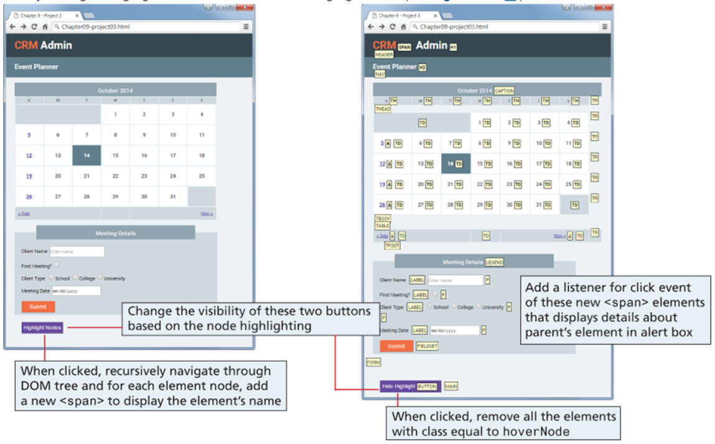

Submitting

Submit the entire project in a zipped folder to eClass, including all resources. Name the as assign3_firstname1_ firstname2_ firstname3

Marking

Completeness: 2 points

Correctness: 2 points

Documentation: 1 point